LOCAL K8 Setup Using Kubeadm
Create 2 VMs with Port as below.
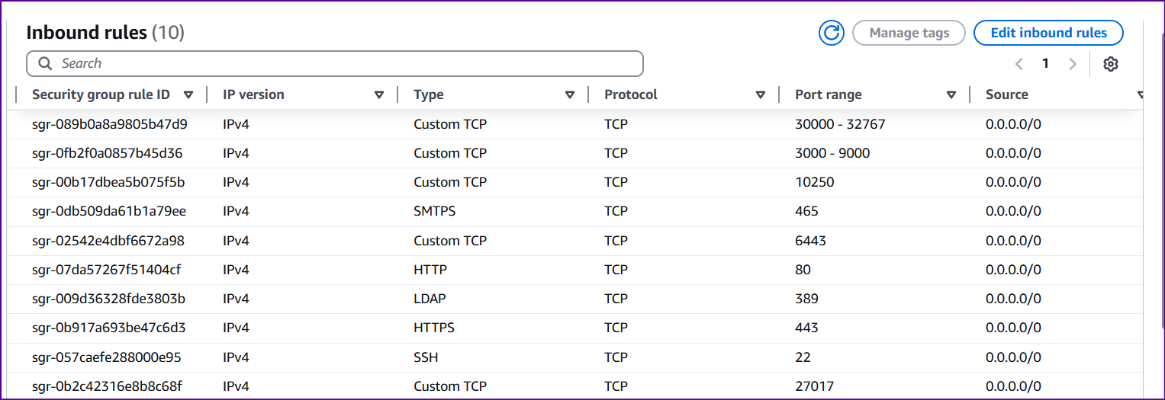
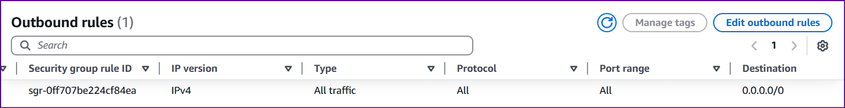
🧱 Step 1: Run on All Nodes (Master + Workers)
# 1. Update
sudo apt update && sudo apt upgrade -y

# 2. Disable Swap (required by kubelet)
sudo swapoff -a
sudo sed -i '/ swap / s/^/#/' /etc/fstab

# 3. Load required kernel modules
cat <<EOF | sudo tee /etc/modules-load.d/containerd.conf
overlay
br_netfilter
EOF

sudo modprobe overlay
sudo modprobe br_netfilter

# 4. Set sysctl parameters
cat <<EOF | sudo tee /etc/sysctl.d/k8s.conf
net.bridge.bridge-nf-call-iptables = 1
net.bridge.bridge-nf-call-ip6tables = 1
net.ipv4.ip_forward = 1
EOF

sudo sysctl --system

🐳 Step 2: Install containerd
# 1. Install containerd dependencies
sudo apt install -y curl gnupg2 software-properties-common apt-transport-https ca-certificates

# 2. Add Docker GPG key and repo
curl -fsSL https://download.docker.com/linux/ubuntu/gpg | sudo gpg --dearmor -o /etc/apt/keyrings/docker.gpg
echo "deb [arch=$(dpkg --print-architecture) signed-by=/etc/apt/keyrings/docker.gpg] \
https://download.docker.com/linux/ubuntu $(lsb_release -cs) stable" | \
sudo tee /etc/apt/sources.list.d/docker.list > /dev/null

# 3. Install containerd
sudo apt update && sudo apt install -y containerd.io

# 4. Generate default config
sudo mkdir -p /etc/containerd
containerd config default | sudo tee /etc/containerd/config.toml > /dev/null

# 5. Enable systemd cgroup driver
sudo sed -i 's/SystemdCgroup = false/SystemdCgroup = true/' /etc/containerd/config.toml

# 6. Restart containerd
sudo systemctl restart containerd
sudo systemctl enable containerd

☸️ Step 3: Install Kubernetes
# 1. Add Kubernetes GPG key and repo
sudo mkdir -p /etc/apt/keyrings
curl -fsSL https://pkgs.k8s.io/core:/stable:/v1.30/deb/Release.key | \
sudo gpg --dearmor -o /etc/apt/keyrings/kubernetes-apt-keyring.gpg

echo "deb [signed-by=/etc/apt/keyrings/kubernetes-apt-keyring.gpg] https://pkgs.k8s.io/core:/stable:/v1.30/deb/ /" | \
sudo tee /etc/apt/sources.list.d/kubernetes.list

# 2. Install kubeadm, kubelet, kubectl
sudo apt update
sudo apt install -y kubelet kubeadm kubectl
sudo apt-mark hold kubelet kubeadm kubectl

🧠 Step 4: Initialize the Control Plane (Master)
sudo kubeadm init --pod-network-cidr=192.168.0.0/16
📌 Save the kubeadm join ... command shown in the output.

⚙️ Step 5: Configure kubectl on Master
mkdir -p $HOME/.kube
sudo cp -i /etc/kubernetes/admin.conf $HOME/.kube/config
sudo chown $(id -u):$(id -g) $HOME/.kube/config

🌐 Step 6: Install Calico CNI Plugin
kubectl apply -f https://raw.githubusercontent.com/projectcalico/calico/v3.27.3/manifests/calico.yaml

🧩 Step 7: Join Worker Nodes
On each worker node (from the join command you copied earlier):
sudo kubeadm join <MASTER-IP>:6443 --token <TOKEN> --discovery-token-ca-cert-hash sha256:<HASH>

✅ Fix for CoreDNS Corefile
- Run:
kubectl -n kube-system edit configmap coredns
- Replace this section:
forward . /etc/resolv.conf {
max_concurrent 1000
}
- With this block (correctly indented):
forward . 8.8.8.8 1.1.1.1 {
max_concurrent 1000
}
The full working Corefile should look like this:
Corefile: |
.:53 {
errors
health {
lameduck 5s
}
ready
kubernetes cluster.local in-addr.arpa ip6.arpa {
pods insecure
fallthrough in-addr.arpa ip6.arpa
ttl 30
}
prometheus :9153
forward . 8.8.8.8 1.1.1.1 {
max_concurrent 1000
}
cache 30
loop
reload
loadbalance
}

🚨 Tips:
- Make sure you don't touch the indentation of other blocks.
- The forward block should have 2 spaces more than the .:53 line.
- Avoid using Tab; only use spaces.

🔄 After saving the file:
Restart CoreDNS:
kubectl rollout restart deployment coredns -n kube-system

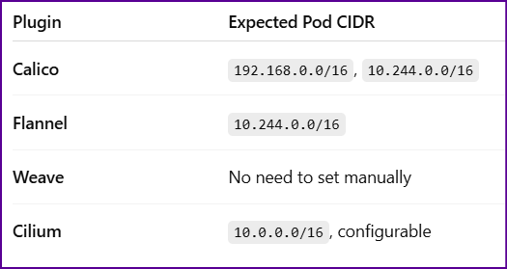

Projects Used:
https://github.com/jaiswaladi246/Boardgame.git

https://github.com/jaiswaladi246/Multi-Tier-BankApp-CD.git

kubectl get nodes To see the worker Nodes
kubectl create ns webapps To create namespace named webapps
kubectl apply -f manifest.yml -n webapps To deploy in namespace named manifest named manifest.yaml
kubectl describe pod podname -n webapps check pod events
kubectl logs podname -n webapps check logs of the pod

